Saurabh Yadav - 150096724010

Java Lab Assignment

Write a program to print all natural numbers in reverse.

public class NaturalNumReverse {

public static void main(String[] args) {

*//Write a program to print all natural numbers in reverse.*

int num = 12345;

int reverse = 0;

while(num != 0) {

int digit = num % 10;

reverse = reverse \* 10 + digit;

num /= 10;

}

System.out.println("Reverse of the number is: " + reverse);

}

}

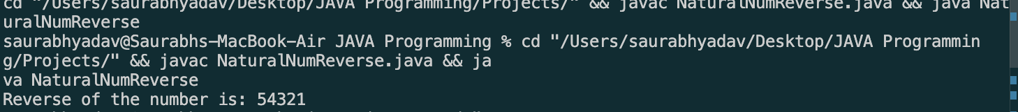

Write a program to print multiplication table of a number.

import java.util.Scanner;

public class MultiplicationTable {

public static void main(String[] args) {

*//Write a program to print multiplication table of a number.*

Scanner sc = new Scanner(System.in);

System.out.println("Enter a number: ");

int num = sc.nextInt();

for(int i = 1; i <= 10; i++) {

System.out.println(num + " \* " + i + " = " + num \* i);

}

sc.close();

}

}

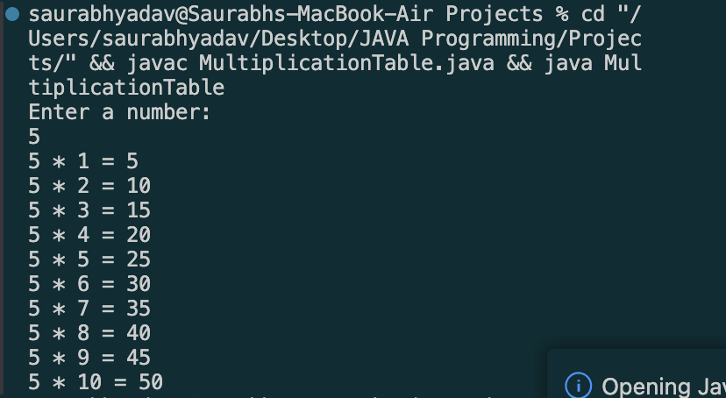

Write a program to print all alphabets from a to z.

public class Alphabet {

public static void main(String[] args) {

*//Write a program to print all alphabets from a to z.*

for(char ch = 'a'; ch <= 'z'; ch++) {

System.out.print(ch + " ");

}

}

}

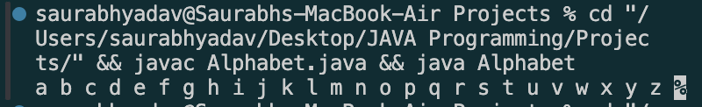

Write a program to print reverse alphabets from Z to A.

public class ReverseAlphabet {

public static void main(String[] args) {

*//Write a program to print reverse alphabets from Z to A.*

for(char ch = 'Z'; ch >= 'A'; ch--) {

System.out.print(ch + " ");

}

}

}

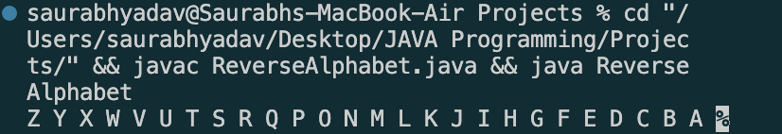

Write a program to print all even numbers between 1 to 50.

public class EvenNumber {

public static void main(String[] args) {

*//Write a program to print all even numbers between 1 to 50.*

for(int i = 1; i <= 50; i++) {

if(i % 2 == 0) {

System.out.print(i + " ");

}

}

}

}

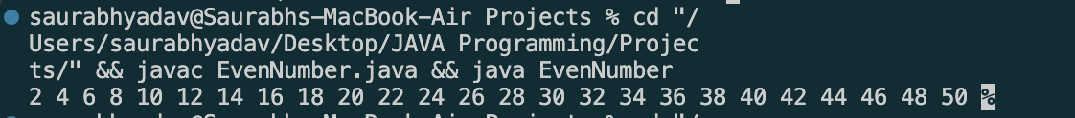

Write a program to print sum of odd numbers between 1 to 50.

public class OddNumber {

public static void main(String[] args) {

*//Write a program to print all odd numbers between 1 to 50.*

for(int i = 1; i <= 50; i++) {

if(i % 2 != 0) {

System.out.print(i + " ");

}

}

}

}



Write a program to read a weekday number and print weekday name using

switch statement.

import java.util.Scanner;

public class WeekdaySwitch {

public static void main(String[] args) {

*//Write a program to read a weekday number and print weekday name using switch statement.*

Scanner sc = new Scanner(System.in);

System.out.println("Enter a weekday number: ");

int weekday = sc.nextInt();

switch(weekday) {

case 1:

System.out.println("Monday");

break;

case 2:

System.out.println("Tuesday");

break;

case 3:

System.out.println("Wednesday");

break;

case 4:

System.out.println("Thursday");

break;

case 5:

System.out.println("Friday");

break;

case 6:

System.out.println("Saturday");

break;

case 7:

System.out.println("Sunday");

break;

default:

System.out.println("Invalid weekday number");

}

}

}

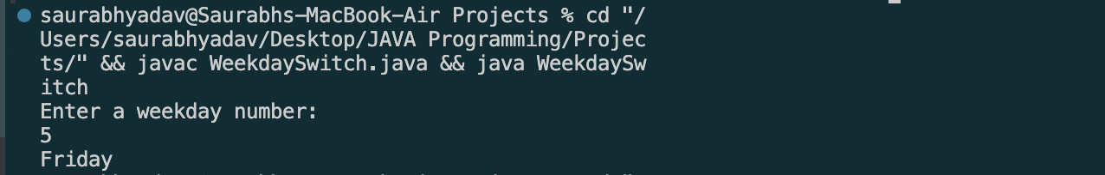

Write a program to Check whether a character is a vowel or consonant using

switch statement.

import java.util.Scanner;

public class SwitchVowel {

public static void main(String[] args) {

Scanner sc = new Scanner(System.in);

System.out.println("Enter a character: ");

char ch = sc.next().charAt(0);

switch (ch) {

case 'a':

System.out.println("Vowel");

break;

case 'e':

System.out.println("Vowel");

break;

case 'i':

System.out.println("Vowel");

break;

case 'o':

System.out.println("Vowel");

break;

case 'u':

System.out.println("Vowel");

break;

default:

System.out.println("Consonant");

}

}

}

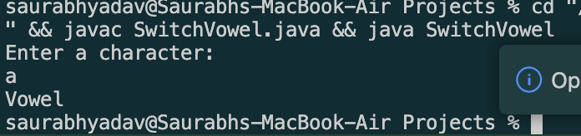

Write a program to reverse the digits of a given integer number.

import java.util.Scanner;

public class ReverseNum {

public static void main(String[] args) {

*//Write a program to reverse the digits of a given integer number.*

Scanner sc = new Scanner(System.in);

System.out.println("Enter a number: ");

int num = sc.nextInt();

int reverse = 0;

while(num != 0) {

int digit = num % 10;

reverse = reverse \* 10 + digit;

num /= 10;

}

System.out.println("Reverse of the number is: " + reverse);

sc.close();

}

}

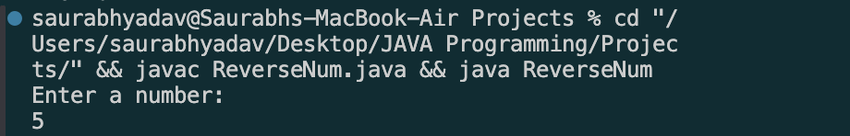

Write a program to find sum of digits of a number.

import java.util.Scanner;

public class SumOfDigits {

public static void main(String[] args) {

*//Write a program to find sum of digits of a number.*

Scanner sc = new Scanner(System.in);

System.out.println("Enter a number: ");

int num = sc.nextInt();

int sum = 0;

while(num != 0) {

int digit = num % 10;

sum += digit;

num /= 10;

}

System.out.println("Sum of the digits is: " + sum);

sc.close();

}

}

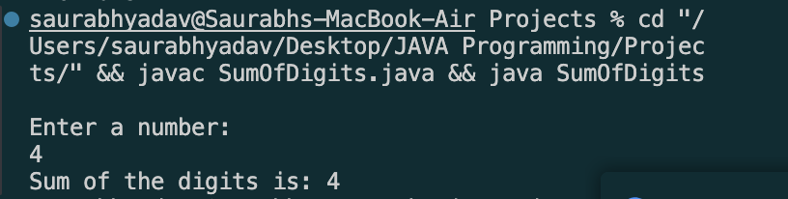

WAP to check whether the inputted number is Armstrong Number or not.

import java.util.Scanner;

import java.lang.Math;

public class ArmStrongNumber {

public static void main(String[] args) {

Scanner sc = new Scanner(System.in);

System.out.println("Enter a number: ");

int num = sc.nextInt();

int temp = num;

int sum = 0;

while (num > 0) {

int rem = num % 10;

sum += Math.pow(rem, 3);

num /= 10;

}

if (temp == sum) {

System.out.println("Armstrong Number");

} else {

System.out.println("Not Armstrong Number");

}

sc.close();

}

}

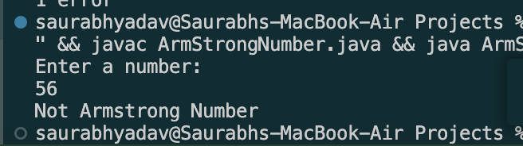

Write a Java program to check if a given number is a prime number.

import java.util.Scanner;

public class CheckPrimeNumber {

public static void main(String[] args) {

Scanner sc = new Scanner(System.in);

System.out.println("Enter a number: ");

int num = sc.nextInt();

boolean isPrime = true;

if ( num <= 1) {

isPrime = false;

} else {

for (int i = 2; i <= Math.sqrt(num); i++) {

if (num % i == 0) {

isPrime = false;

break;

}

}

}

if (isPrime) {

System.out.println("Prime Number");

} else {

System.out.println("Not Prime Number");

}

}

}

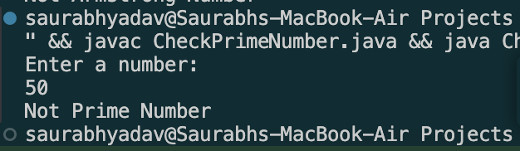

Write a menu based Java program for performing different arithmetic

Operations.

import java.util.Scanner;

public class MenuBased {

public static void main(String[] args) {

*//Write a menu based Java program for performing different arithmetic operations*

Scanner sc = new Scanner(System.in);

while(true) {

System.out.println("1. Addition");

System.out.println("2. Subtraction");

System.out.println("3. Multiplication");

System.out.println("4. Division");

System.out.println("5. Exit");

System.out.println("Enter your choice: ");

int choice = sc.nextInt();

if(choice == 5) {

break;

}

System.out.println("Enter two numbers: ");

int a = sc.nextInt();

int b = sc.nextInt();

switch(choice) {

case 1:

System.out.println("Sum: " + (a + b));

break;

case 2:

System.out.println("Difference: " + (a - b));

break;

case 3:

System.out.println("Product: " + (a \* b));

break;

case 4:

System.out.println("Quotient: " + (a / b));

break;

default:

System.out.println("Invalid choice!");

sc.close();

}

}

}

}

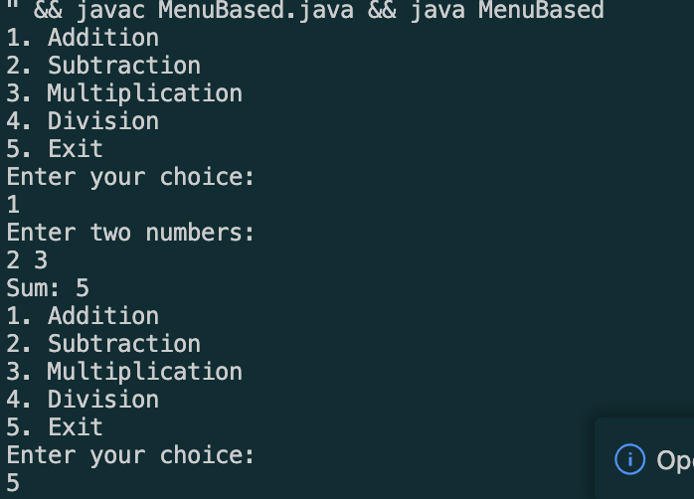

WAP to find average of consecutive N Odd numbers and even numbers.

public class ConsecutiveOddEven {

public static void main(String[] args) {

*//WAP to find average of consecutive N Odd numbers and even numbers.*

int n = 10;

int oddSum = 0;

int evenSum = 0;

int oddCount = 0;

int evenCount = 0;

int i = 1;

while(oddCount < n || evenCount < n) {

if(i % 2 != 0) {

oddSum += i;

oddCount++;

} else {

evenSum += i;

evenCount++;

}

i++;

}

System.out.println("Average of first " + n + " odd numbers: " + (oddSum / n));

System.out.println("Average of first " + n + " even numbers: " + (evenSum / n));

}

}

